**Slack bots series - Slash Command Accelerator**

**Verification Guide**

Revision History

|  |  |  |
| --- | --- | --- |
| **Author** | **Revision Number** | **Date** |
| TCSCODER | 1.0 | 01.14.2018 |
|  |  |  |
|  |  |  |

Deployment Instructions 3

1. Organization of Submission 3

2. Configuration 3

3. Application Setup 3

3.1. Creates a Slack app 3

3.2. Build the example project 6

3.3. Deploy to Heroku 6

3.4. Add Slash Commands 7

4. Verification 9

5. Resource Contact List 13

# Deployment Instructions

# Organization of Submission

|  |  |
| --- | --- |
| **Path** | **Description** |
| docs | Contains the documents. |
| example | The example project for showing the usage of the framework. |
| lib | The source code of the framework. |
| template | The template project. |
| README.md | The README file showing the usage of the framework. |
| package.json | The node package file. |
| index.js | The entry of the framework. |

# Configuration

In the ./example/config/default.js contains the configuration of the example project.

|  |  |
| --- | --- |
| **Path** | **Description** |
| SLACK_APP_CLIENT_ID | the slack app's client ID |
| SLACK_APP_CLIENT_SECRET | the slack app's client secret |
| SLACK_APP_VERIFICATION_TOKEN | the slack app's verification token |
| SLACK_APP_OAUTH_ACCESS_TOKEN | the slack app's oauth access token |
| SLACK_APP_IMMEDIATE_MESSAGE_TIMEOUT_LIMIT | the timeout for immediate message. If the process time is longer than this value, it will send a delay message |
| PORT | The listen port |
| LOG_LEVEL | The log level |

# Application Setup

In this docs, we show how to build and run the example project.

# Creates a Slack app

In this page: <https://api.slack.com/apps>

Click button Create New App to create a new app.

Then in the Settings – Basic Information – App Credentials section:

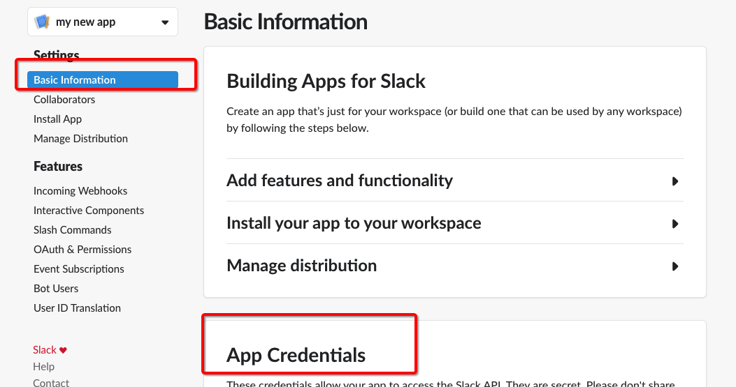

You can see the client ID, client secret and Verification Token:

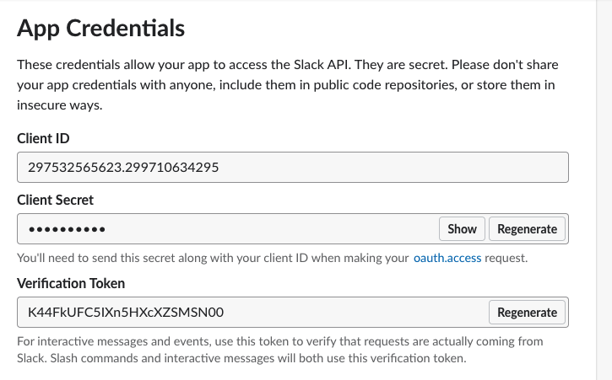

Then, in the Features – Oauth & Permissions,

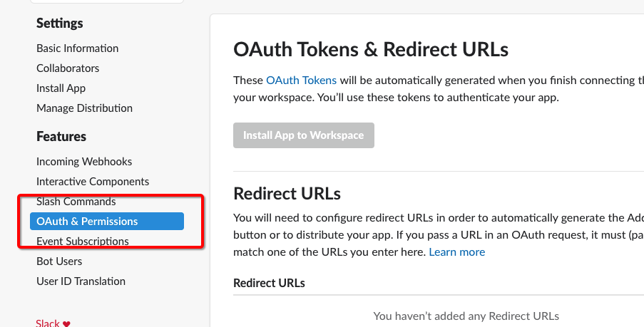

Then in the Scopes section, add users:read scope.

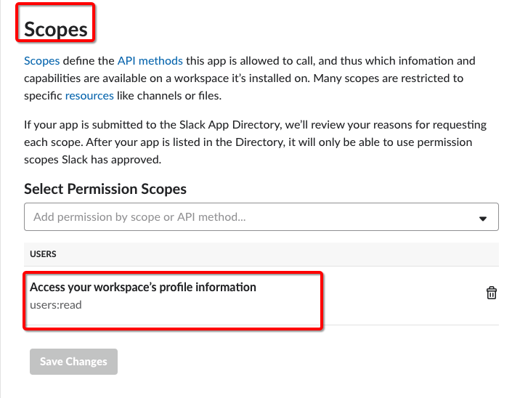

Then click the Install App to Workspace button

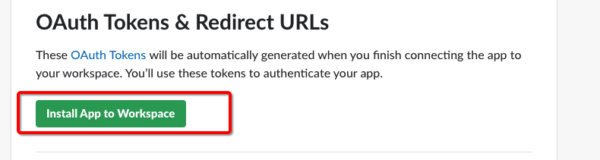

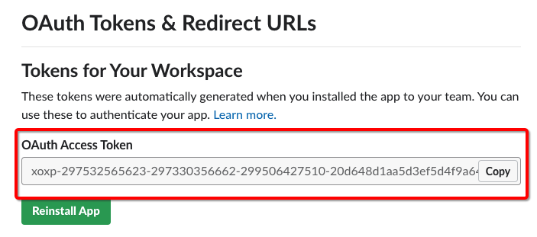

Then you can find the OAuth Access Token.

# Build the example project

In the root directory of this submission, run:

npm install

# Deploy to Heroku

In the root directory of this submission, run:

git init

git add .

git commit -am "init"

heroku login

heroku create

git push -u heroku master

heroku config:set SLACK_APP_CLIENT_ID='****'

heroku config:set SLACK_APP_CLIENT_SECRET='*****',

heroku config:set SLACK_APP_VERIFICATION_TOKEN='*****'

heroku config:set SLACK_APP_OAUTH_ACCESS_TOKEN='******'

please remember your heroku host name.

# Add Slash Commands



Click the Slash Commands and Create New Command button to create a new slash command:



In the Request URL blank, fill the url like https://<heroku-host>/commands

<heroku-host> should be replaced to your heroku host name.

Similarly, create all these 4 commands: /hello, /show, /delay, /hello-with-button:



Note, once you added new Slash Command, you should reinstall the app to workspace and update the OAuth Access Token configuration.



In the Features – Interactive Compoents section, click the ‘Enable Interactive Components” button,



In that Request URL, fill: https://<your-heroku-host>/actions

# Verification

The verification video is: <https://youtu.be/2riMgmyDbZU>

**/hello** - *a hello world demo*

Run /hello, it shows:



Run /hello help, it shows:

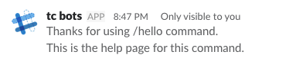

**/hello-with-button** - *a hello world demo with showing buttons*

Run /hello-with-button, it shows:

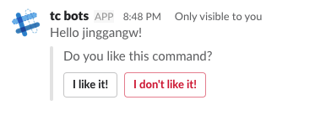

**/show** - *shows button, image, menu or user role*

Run /show help, it shows:

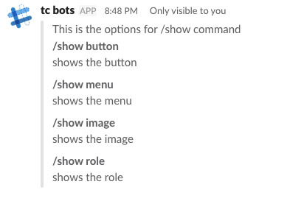

Run /show button, it shows:

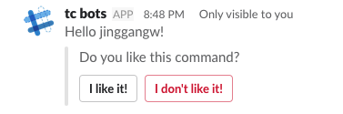

Run /show image, it shows:

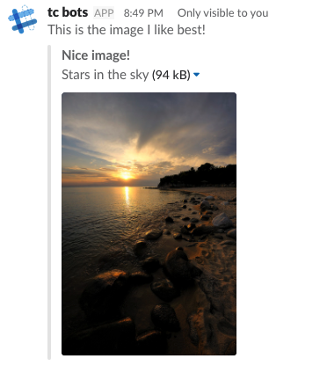

Run /show menu, it shows:

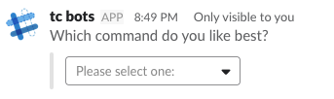

Run /show role, it shows:

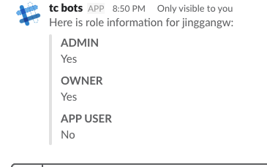

**/delay** - *demo for a delay message*

Run /delay 5000, it will send the message after 5 seconds.



Now if the message is send with delay >= 2 seconds, it is a delay message, otherwise it is an immediate message. You can see that these 2 kinds of messages are totally transparent.

# Resource Contact List

|  |  |
| --- | --- |
| **Name** | **Resource Email** |
| TCSCODER | Use contact option from tc profile |